1st Party System and French Revolution – VA and KY Resolutions

Check out Cabinet Battle #2, and answer the following question:

1. How did Hamilton and Jefferson (and what would become the parties they led) differ over their views of the French Revolution and its consequences (war with Great Britain)?

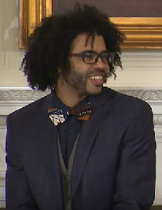

VS.

2. Jay’s Treaty (1795) gave PREFERENTIAL trading status to Great Britain, making them America’s #1 trading partner during the height of conflict between France and Great Britain.
- Why could France feel betrayed?
- Why would this upset Jefferson and his supporters?

3. Jay’s Treaty was a major cause of the XYZ Affair. Please describe the incident and how it led to many Americans wanted to go to war with France.

4. How did the Alien and Sedition Acts illustrate tensions between the Federalists and Democratic-Republicans?

5. Why did the Federalists design the Alien and Sedition Acts to expire in two years in 1800?

6. Do states have the ability to nullify federal laws? (Yes or No). What theory did Jefferson and Madison use to argue they could?

7. According to the APUSH Curriculum, the following are major reasons for the development of the first political parties (Democratic-Republicans and Federalists):
- Foreign Policy (Such as The French Revolution, Jay’s Treaty, etc.)
- Economic Policy (Such as Hamilton’s Financial Plan)
- Relationship between the national government and the states (Such as states’ rights vs. power of federal government, VA and KY Resolutions, etc.)

A. Briefly explain how ONE of the following was most significant in the formation of political parties in the late-18th century:
- Relationship between the national government and the states
- Economic policy
- Foreign policy
B. Provide ONE piece of historical evidence that supports your choice in part a.
C. Briefly explain why one of the other options is not as significant in the formation of political parties in the late 18th century.

