Name: _____________________________________________
Articles of Confederation and the Constitution

Complete the Venn Diagram comparing the Articles and the Constitution. Topics to include: currency, trade and tariff issues, national military, rebellions, amending each document, representation, branches of government, rebellions, etc.

Constitution
Articles of Confederation

Identify 3 issues under the Articles of Confederation and explain how the Constitution rectified those issues.

a. _______________________________________________________________________________________________________________________________________________________________ _________________________________________________________________________________________________________________________________________________________________ ____________________________________________________________________________________________________________________________________________________________________________________________________________________________________________________________________________________________________________________________________________________________________________________________________________________________________________________________________________________________________________________________________________________________________________________________________________________________________________________________________

b. _______________________________________________________________________________________________________________________________________________________________ _________________________________________________________________________________________________________________________________________________________________ ____________________________________________________________________________________________________________________________________________________________________________________________________________________________________________________________________________________________________________________________________________________________________________________________________________________________________________________________________________________________________________________________________________________________________________________________________________________________________________________________________

c. _______________________________________________________________________________________________________________________________________________________________ _________________________________________________________________________________________________________________________________________________________________ ____________________________________________________________________________________________________________________________________________________________________________________________________________________________________________________________________________________________________________________________________________________________________________________________________________________________________________________________________________________________________________________________________________________________________________________________________________________________________________________________________

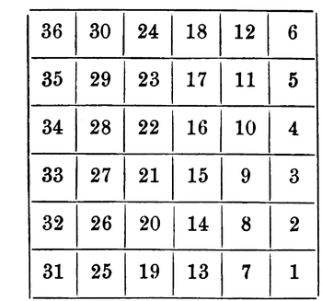
Identify and explain ONE major success of the Articles of Confederation.

__________________________________________________________________________________________________________________________________________________________________________________________________________________________ __________________________________________________________________________________________________________________________________________________________________________________________________________________________ ______________________________________________________________________________________________________________________________________________________________________________________________________________________________________________________________________________________________________________________________________________________________________________________________________________________________________________________________________________________________________________________________________________________________________________________________________________________________________________________________________________

