Name: _______________________________________________
Constitution – John Adams Analysis Sheet

1. Please summarize the following:
New Jersey Plan - __________________________ __________________________________________________________________________________________________________________________________________________________________________________________________________________________________________________________________________________________
Virginia Plan - ______________________________ __________________________________________________________________________________________________________________________________________________________________________________________________________________________________________________________________________________________

Great Compromise- ________________________ __________________________________________________________________________________________________________________________________________________________________________________________________________________________________________________________________________________________

2. How were slaves counted towards representation in Congress? ______________________________________________________________________________________ _________________________________________________________________________________________________________________________________________________________________

3. According to the Constitution, what could be outlawed as early as 1808? ___________________________________________________________________________

4. What does the elastic clause allow the government to do? ____________________________________________________________________________________________ _________________________________________________________________________________________________________________________________________________________________

5. What was the purpose of the Federalist Papers? _______________________________________________________________________________________________________ _________________________________________________________________________________________________________________________________________________________________

6. Why were the Bill of Rights added to the Constitution? ________________________________________________________________________________________________ _________________________________________________________________________________________________________________________________________________________________

7. Select two problems of the Articles of Confederation and explain how the Constitution rectified those issues.
- __________________________________________________________________________________________________________________________________________________________________________________________________________________________________________________________________________________________________________________
- __________________________________________________________________________________________________________________________________________________________________________________________________________________________________________________________________________________________________________________

8. How did the Whiskey Rebellion demonstrate the effectiveness of the Constitution compared to Shays’ Rebellion and the Articles of Confederation? _______________________________________________________________________________________________________________________________________________ _________________________________________________________________________________________________________________________________________________________________
__________________________________________________________________________________________________________________________________________________________________________________________________________________________________________________________________________________________________________________________________

9. Select two of the following and explain how they were the most significant in contributing to the development of the 1st Party System:
- Economic Issues, Foreign Policy Issues, Role of the federal government
- __________________________________________________________________________________________________________________________________________________________________________________________________________________________________________________________________________________________________________________
- __________________________________________________________________________________________________________________________________________________________________________________________________________________________________________________________________________________________________________________

10. Complete the following table below about the First Party System.
 | Democratic-Republicans | Federalists
Foreign policy favored this nation
View of the National Bank (BUS)
Interpretation of the Constitution
People that supported this party were likely to be
Economy should be based on

11. Place the following events in the correct order (Label 1 – 4):
____________: Quasi War
____________: XYZ Affair
____________: Jay’s Treaty
____________: Alien and Sedition Acts
Which event above caused the most tension between the Democratic-Republicans and Federalists? Why? ________________________________________
__________________________________________________________________________________________________________________________________________________________________________________________________________________________________________________________________________________________________________________________________

Question 12 is based on the following excerpt:
“It is our true policy to steer clear of permanent alliances with any portion of the foreign world; so far, I mean, as we are now at liberty to do it; for let me not be understood as capable of patronizing infidelity to existing engagements. I hold the maxim no less applicable to public than to private affairs, that honesty is always the best policy. I repeat it, therefore, let those engagements be observed in their genuine sense. But, in my opinion, it is unnecessary and would be unwise to extend them.”
- George Washington, 1796

12. What was Washington’s advice about foreign countries? Does the US follow this advice today? _________________________________________________ _________________________________________________________________________________________________________________________________________________________________
_________________________________________________________________________________________________________________________________________________________________

Questions 13 – 14 are based on the following political cartoon:
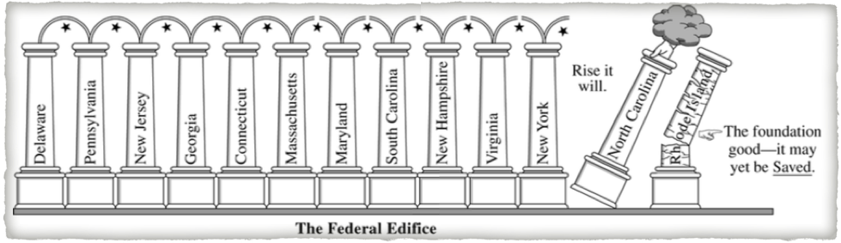
13. According to the cartoon, what is the point of view towards a strong central government? ______________________________________________________ _________________________________________________________________________________________________________________________________________________________________

14. Many anti-Federalists opposed the Constitution until there was a promise to add what? _________________________________________________________ _________________________________________________________________________________________________________________________________________________________________

