Name: __________________________________________
Henry Clay’s American System Analysis Sheet

Identify and Describe the Three Parts of Henry Clay’s American System

Part II: ______________________________ __________________________________________________________________________________________________________________________________________________________________________________________________________________________________________
Part III: _____________________________ __________________________________________________________________________________________________________________________________________________________________________________________________________________________________________
Part I: _______________________________ __________________________________________________________________________________________________________________________________________________________________________________________________________________________________________

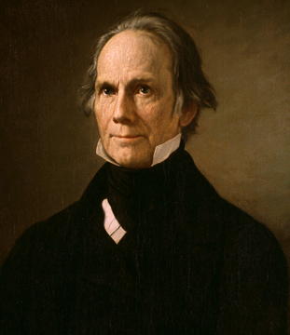
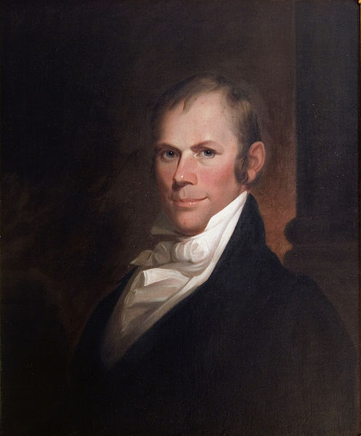

Henry Clay’s American System!

1. How would the following people most likely view the American System? Why?
- Alexander Hamilton: _________________________________________________________________________________________________________________________________ __________________________________________________________________________________________________________________________________________________________________________________________________________________________________________________________________________________________________________________
- Thomas Jefferson from the 1790s: __________________________________________________________________________________________________________________ __________________________________________________________________________________________________________________________________________________________________________________________________________________________________________________________________________________________________________________
2. What did the Supreme Court state about the Bank of the US in its 1819 decision, McCulloch v. Maryland? _______________________________________ _________________________________________________________________________________________________________________________________________________________________
Part II Document Analysis

“Sir, I am convinced that it would be… unjust, to aggravate the burdens of the people for the purpose of favoring the manufacturers; for this government created and gave power to Congress to regulate commerce and equalize duties on the whole of the United States, and not to lay a duty but with a steady eye to revenue. With my goodwill, sir, (no) one interest in the country (should be) sacrificed by the management of taxation to another… The agriculturalists bear the whole brunt of the war and taxation, and remain poor, while the others run in the ring of pleasure, and fatten upon them.” – John Randolph, 1816

1. What is the message of the document? __________________________________________________________________________________________________________________ __________________________________________________________________________________________________________________________________________________________________________________________________________________________________________________________________________________________________________________________________

2. What is the Point of View of the document? _____________________________________________________________________________________________________________
__________________________________________________________________________________________________________________________________________________________________________________________________________________________________________________________________________________________________________________________________

3. The excerpt was likely to have found the most support among which of the following groups?
- New England merchants
- Factory workers in the North
- Plantation owners in South Carolina
- Irish immigrants that helped build the Erie Canal

Part III: Sentence Prompt

Complete the following prompt with at least three additional sentences that supports the prompt.

1. The American System was somewhat successful. ______________________________________________________________________________________________________ __________________________________________________________________________________________________________________________________________________________________________________________________________________________________________________________________________________________________________________________________
______________________________________________________________________________________________________________________________________________________________________________________________________________________________________________________________________________________________________________________________________________________________________________________________________________________________________________________________________________________________________________________________________________________________________________________________________________________________________________________________________________________________________________________________________________________________________________________________________________________________________________________________________________________________________________________________________________________________________________________________________
__________________________________________________________________________________________________________________________________________________________________________________________________________________________________________________________________________________________________________________________________

