Name: _________________________________________
APUSH Review: Breaking Down John Gast’s American Progress, 1872

Cartoon Analysis Questions

- How would the following view the image?
  - Natives: __________________________________________________________________ ____________________________________________________________________________
  - Frederick Jackson Turner: _____________________________________________ ____________________________________________________________________________
  - Farmers hoping to prosper out West: _________________________________ ____________________________________________________________________________

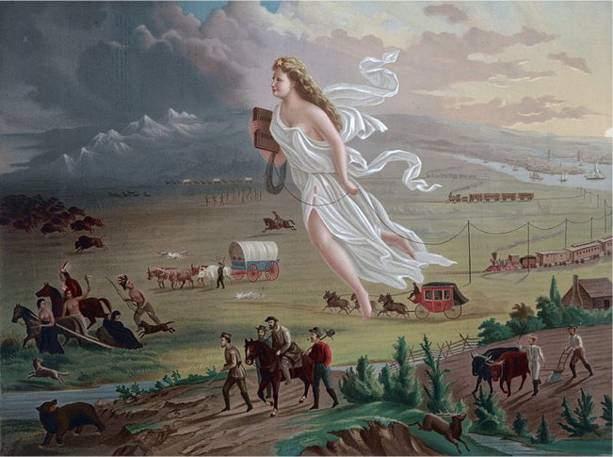

HIPP Analysis

1. What is the Historical Circumstance of this illustration?
___________________________________________________________________________________________________________________________________________________________________________________________________________________________________________________________________________________________________
Flip it over for more HIPP

2. Who is the Intended Audience of this illustration?
___________________________________________________________________________________________________________________________________________________________________________________________________________________________________________________________________________________________________

3. What is the Point of View of the illustration?
___________________________________________________________________________________________________________________________________________________________________________________________________________________________________________________________________________________________________

4. What is the Purpose of this illustration?
___________________________________________________________________________________________________________________________________________________________________________________________________________________________________________________________________________________________________

