Name: ____________________________________________
“Old” Immigration Multiple-Choice

The following questions are based on the political cartoon below:

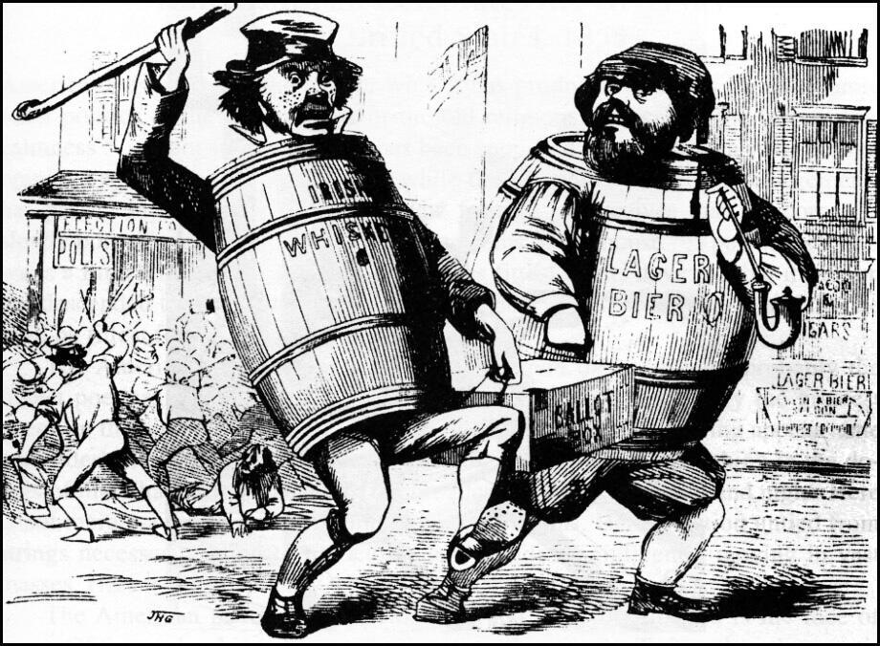

1. The creator of the image would most likely agree with which of the following statements?
- Irish and German Immigrants made positive contributions to American society
- Rising xenophobia should not be a concern of Americans
- Immigrants’ political power should be limited
- Immigrants should retain their religious and cultural practices in the United States

2. The immigrants represented in the cartoon most likely settled in which two regions of the United States?
- The Northeast and Midwest
- The South and Southwest
- The West Coast and Great Plains
- The Pacific Northwest and Southwest

3. The sentiments illustrated in the cartoon are most consistent with what other circumstances in US History?
- The abolitionist movement in Antebellum America
- The desire for restrictive immigration quotas in the 1920s
- Anti-imperialists that sought to limit US expansion overseas
- The goals of Radical Republicans during Reconstruction

