Name: _____________________________________
Colonial America Mystery Document

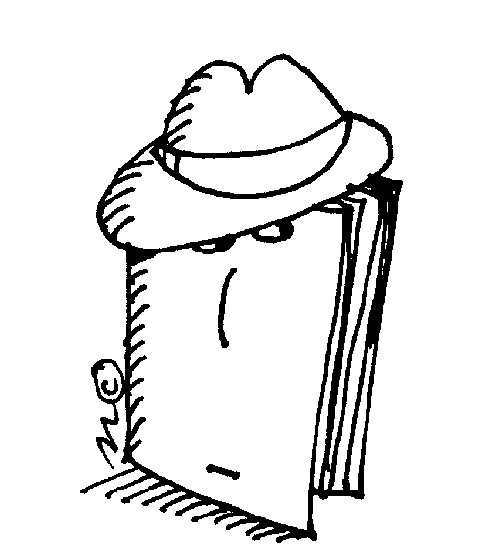
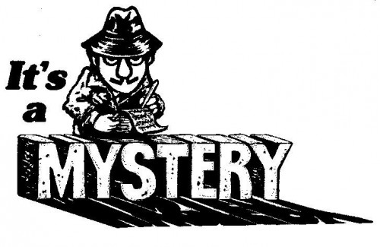

And We do further declare it to be Our Royal Will and Pleasure, for the present as aforesaid, to reserve under our Sovereignty, Protection, and Dominion, for the use of the said Indians, all the Lands and Territories not included within the Limits of Our said Three new Governments, or within the Limits of the Territory granted to the Hudson's Bay Company, as also all the Lands and Territories lying to the Westward of the Sources of the Rivers which fall into the Sea from the West and North West as aforesaid.

And We do hereby strictly forbid, on Pain of our Displeasure, all our loving Subjects from making any Purchases or Settlements whatever, or taking Possession of any of the Lands above reserved, without our especial leave and Licence for that Purpose first obtained.

And We do further strictly enjoin and require all Persons whatever who have either wilfully or inadvertently seated themselves upon any Lands within the Countries above described. or upon any other Lands which, not having been ceded to or purchased by Us, are still reserved to the said Indians as aforesaid, forthwith to remove themselves from such Settlements.
1. What is the above excerpt from? _____________________________________________________________________

2. What gave it away? ________________________________________________________________________________ ____________________________________________________________________________________________________________________________________________________________________________________________________

3. What was the reaction to this document? ______________________________________________________________ ____________________________________________________________________________________________________________________________________________________________________________________________________

4. What was the cause of this document? ________________________________________________________________ __________________________________________________________________________________________________

5. What were the effects of this document? ______________________________________________________________ ____________________________________________________________________________________________________________________________________________________________________________________________________

