Name: ______________________________
Breaking Down A Political Cartoon About The Embargo Act

Background Info

- British-American relations were at a low in early-19th century
  - Impressment. What is it? ______________________________________________________ __________________________________________________________________________________________________________________________________________________
  - Britain armed ___________________ on the __________________________
  - _______________________________________________________________________

The Political Cartoon
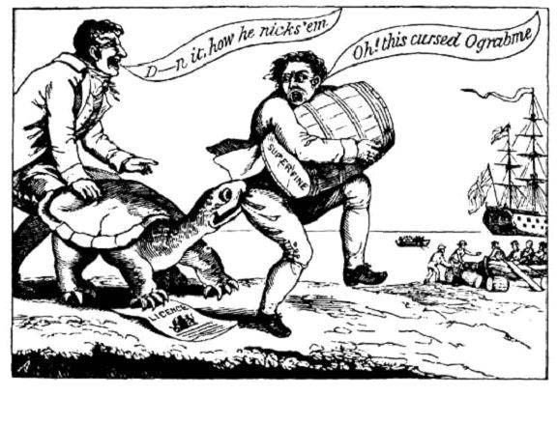

HIPP Time!

- Historical Context?
  - Tensions with ________________________________________________
  - ____________________________________

- Intended Audience?
  - ______________________________________________________________________________________________________________________________________________________
- Purpose?
  - ______________________________________________________________________________________________________________________________________________________
- Point of View?
  - ______________________________________________________________________________________________________________________________________________________

