Name: ____________________________________
John Marshall and the Supreme Court Analysis Sheet

Here’s what the APUSH Curriculum says about the Marshall Court:

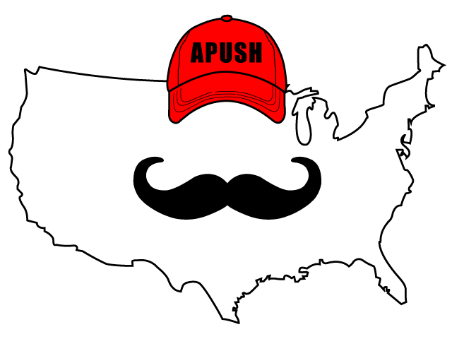

Key Concept 4.1, I, B:
- “Supreme Court decisions established the primacy of the judiciary in determining the meaning of the Constitution and asserted that federal laws took precedence over state laws.”

1. What court case established the “primacy of the judiciary….”?
- Marbury v. Madison - established _____________________________________________________
  - Supreme Court can declare a law _____________________________________________

2. Briefly explain two court cases that “asserted that federal laws took precedence over state laws”?
  - ___________________________________________________________________________________________________________________________________________________________________________________________________________________________________________________________________________________________________________________________
  - ___________________________________________________________________________________________________________________________________________________________________________________________________________________________________________________________________________________________________________________________

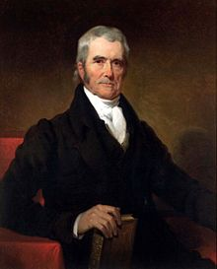
“If any one proposition could command the universal assent of mankind, we might expect it would be this: that the government of the Union, though limited in its powers, is supreme within its sphere of action… Although, among the enumerated powers of government, we do not find the word ‘bank’ or ‘incorporation,’ we find the great powers to lay and collect taxes; to borrow money; to regulate commerce; to declare and conduct a war; and to raise and support armies and navies… We are unanimously of opinion, that the law passed by the legislature of Maryland, imposing a tax on the Bank of the United States, is unconstitutional and void.”
McCulloch v. Maryland, 1819

1. Does the above court case support a strict or loose interpretation of the Constitution? _____________________________________________________________

2. Would the following agree or disagree with the ruling in McCulloch v. Maryland? Why?
- Alexander Hamilton: ________________________________________________________________________________________ _________________________________________________________________________________________________________________
- Thomas Jefferson in the 1790s: ____________________________________________________________________________ ________________________________________________________________________________________________________________

Why Pitbull and Chris Brown should have taken APUSH……

I don’t know for sure, but I’m guessing that Pitbull and Chris Brown did not take APUSH. If they did, they forgot an important concept from the course; the definition of international.

Released in 2011, the song focuses on places Pitbull has traveled through his stardom. I want to focus on is the chorus of the song, which is sung by Chris Brown:

You put it down like New York City
I never sleep
Wild like Los Angeles
My fantasy
Hotter than Miami
I feel the heat
Ohh, girl, this international love
Ohh, this international love

Inter means 2 or more. (For example, in the court case Gibbons v. Ogden, John Marshall stated that only Congress could control INTERstate trade – trade between two or more states.)

In the chorus, Pitbull and Chris Brown mention cities that are located ONLY in the United States; thus it is not international love. It should be intranational (intra, meaning within the country) love.

