Name: _______________________________________________
Document Analysis – Irish and German Immigrants
Irish Whiskey

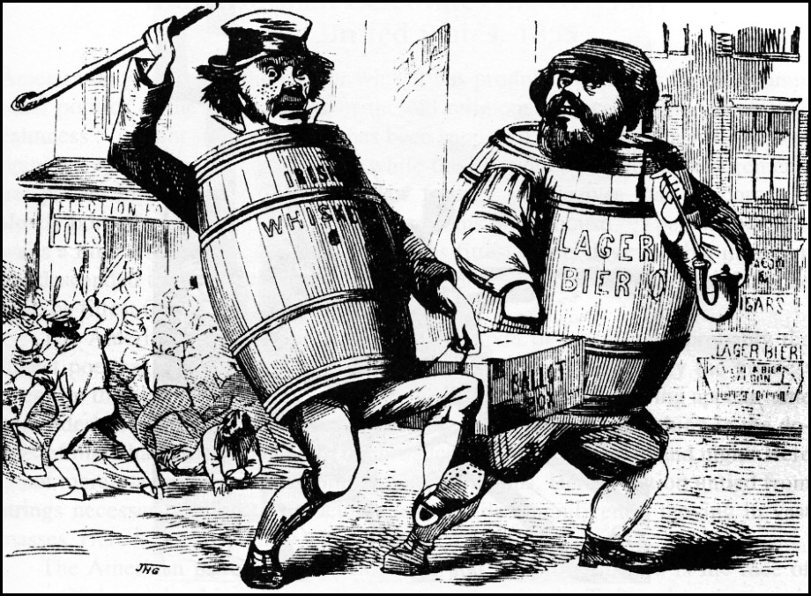
Ballot Box

1. What is the point of view of the cartoon? (Positive? Negative?) ______________________________ __________________________________________________________________________________________
____________________________________________________________________________________________________________________________________________________________________________________

Flip Over for more questions!
2. What political party did the immigrants represented in the cartoon tend to support? __________________________________________________________________________________________

3. Where did the immigrants represented in the cartoon tend to settle? _______________________ __________________________________________________________________________________________

4. How would the Know-Nothing Party view the cartoon? _______________________________________ ____________________________________________________________________________________________________________________________________________________________________________________

5. What are other examples of Nativism in US History? __________________________________________ __________________________________________________________________________________________________________________________________________________________________________________________________________________________________________________________________________________________________________________________________________________________________________________________________________________________________________________________________
HIPP
1. What is the Historical Circumstance of this document?
___________________________________________________________________________________________________________________________________________________________________________________________________________________________________________________________________________________________________________________________

2. Who is the Intended Audience of this document?
___________________________________________________________________________________________________________________________________________________________________________________________________________________________________________________________________________________________________________________________

3. What is the Point of View of the document?
___________________________________________________________________________________________________________________________________________________________________________________________________________________________________________________________________________________________________________________________

4. What is the Purpose of this document?
___________________________________________________________________________________________________________________________________________________________________________________________________________________________________________________________________________________________________________________________

