Name: ____________________________________________________
APUSH Review: Causes of Sectional Conflict: 1820 - 1860

Big Ideas To Know

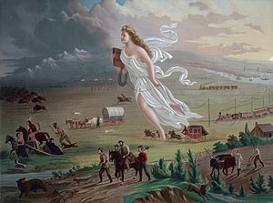
- Westward expansion (_______________________________________) was a HUGE cause of conflict
  - Would the new land be _____________________________?
- The Mexican-American War was a watershed event (________________ ________________________________)
- As time went on, Compromises did not solve issues, but made them worse (Fugitive Slave Act - 1850, Kansas-Nebraska Act)
- Abe Lincoln campaigned on the nonextension of slavery (_____________ ___________________ platform)

Missouri Compromise (1820)

- Missouri applied to be a state in the Louisiana Territory - would upset ________________ of free and slave states
- ________________________________________ - would allow for emancipation of children of slaves
  - House approved, Senate rejected
- The Compromise?
  - _____________________ enters as a slave state
  - _____________________ added as a free state
  - ________________ - above would be free, below would be slave
- How did it lead to increased tensions?
  - Desire to keep a balance of free and slave states
  - Overturned by KS-NB Act

Mexican-American War (1846 – 1848)

- US won the war, gained Mexican Cession
- ________________________ Proviso:
  - Proposed banning slavery in all territory gained from Mexico
  - Passed the _____________________, not the Senate
- At the end of the war, TX claimed much more land than they have today
- How did this lead to increased tensions?
  - ______________________________________________

Compromise of 1850

- Series of laws passed in response to Mexican-American War - 5 parts
- _________________________________________ in Mexican Cession
- **____________________________________________________ Act**
  - Webster’s “7th of March Speech”
- Slave trade was abolished in D.C.
- __________________ was added as a free state
- TX paid $ to give up territory
- How did this lead to tensions?
  - Fugitive Slave Law -> ___________________________________
  - Many Northerners turned _______________________________
  - Tensions in Congress

Kansas-Nebraska Act

- Both Kansas and Nebraska were above the 36°30’ in LA Purchase
- Act allowed for ______________________________________________ in KS and NB
  - Assumption was KS would be slave, NB would be free
- How did this lead to increased tensions?
  - Fighting breaks out in Kansas
  - Caning of ____________________________________
  - Republican Party formed as a result - _____________________ platform

Dred Scott (1857)

- Supreme Court ruled that:
  - Slaves were __________________ and could not be taken away
  - ALL African Americans are NOT ___________________
  - Congress could not legislate slavery in the territories (Compromise of 1820 was ______________________________)
- How did it lead to increased tensions?
  - North was furious, many still advocated ____________________ ______________________________ (Stephen Douglas)

Harpers Ferry (1859)

- _________________________ and others tried to lead a slave rebellion
- Took over the 2nd largest arsenal
- Eventually captured, hanged
- How did it lead to increased tensions?
  - The South saw many in the North as “_____________________ _______________________”

Election of 1860

- 4-way race
  - Douglas, Lincoln, Bell, Breckinridge
- Since the Democrats were split, Lincoln won without winning a single ______________________________________
  - Lincoln ran on a ___________________________ platform
- How did it lead to increased tensions?
  - Many in the South feared Lincoln would abolish slavery
  - Beginning with South Carolina, Southern states began to ___________________

Quick Recap

- ___________________________________________________________
- ___________________________________________________________
- ___________________________________________________________
- ___________________________________________________________
- ___________________________________________________________
- ___________________________________________________________
- ___________________________________________________________
- ___________________________________________________________

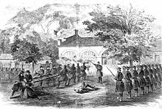

Document Analysis

Document #1
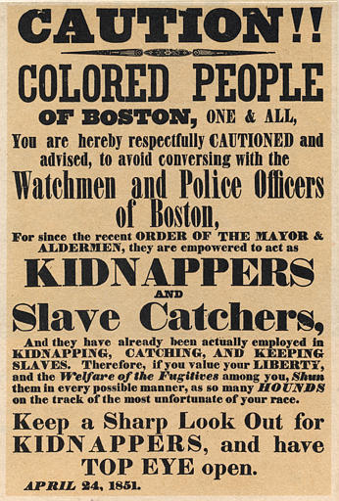
1. What is the purpose of the poster? _________________________________________________________________________ ____________________________________________________________________________________________________________________________________________________________________________________________________________________________________________________________________________________________________________________________________________________________

2. Who is the intended audience? ______________________________________________________________________________
____________________________________________________________________________________________________________________________________________________________________________________________________________________________________________________________________________________________________________________________________________________________

3. How did some states in the North respond to the Fugitive Slave Act? ____________________________________________________________________________________________________________________ ____________________________________________________________________________________________________________________________________________________________________________________________________________________________________________________________________________________________________________________________________________________________

Document #2

"The United States will conquer Mexico, but it will be as the man who swallows the arsenic which brings him down in turn. Mexico will poison us." – Ralph Waldo Emerson, 1846.

1. What is the “poison” that Emerson is referring to? ____________________________________________________________________________________________________________________ ________________________________________________________________________________________________________________________________________________________________________________

2. How could he be viewed as being prescient? Explain using SPECIFIC historical examples. _______________________________________________________________________ ________________________________________________________________________________________________________________________________________________________________________________________________________________________________________________________________________________________________________________________________________________________________________________________________________________________________________________________________________________________________________________________________________________________________________________________________________________________________________________________________________________________________________________________________________________________________________________________________________________________________________________________________________________________________________________
Sentence Prompts

Directions: Below are statements that are true, but need supporting evidence. Please provide 3 ADDITIONAL sentences that back up the Sentence Prompt.

1. The victory in the Mexican-American War was accompanied by a heated controversy over allowing or forbidding slavery in newly acquired territories. ________________________________________________________________________________________________________________________________________________________________________________ ________________________________________________________________________________________________________________________________________________________________________________________________________________________________________________________________________________________________________________________________________________________________________________________________________________________________________________________________________________________________________________________________________________________________________________________________________________________________________________________________________________________________________________________________________________________________________________________________________________________________________________________________________________________________________________

2. The Kansas-Nebraska Act ultimately failed to resolve the issue of slavery in the territories. _____________________________________________________________________ ________________________________________________________________________________________________________________________________________________________________________________ ________________________________________________________________________________________________________________________________________________________________________________________________________________________________________________________________________________________________________________________________________________________________________________________________________________________________________________________________________________________________________________________________________________________________________________________________________________________________________________________________________________________________________________________________________________________________________________________________________________________________________________________________________________________________________________
Short Answer Question

a. Briefly explain how ONE of the following was most significant in creating sectional tensions between the North and South.
- Compromise of 1820 (Missouri Compromise)
- Compromise of 1850
- Kansas-Nebraska Act (1854)
b. Provide ONE piece of historical evidence that supports your choice in part a.
c. Briefly explain why one of the other options is not as significant in the creating sectional tensions between the North and South.
________________________________________________________________________________________________________________________________________________________________________________________________________________________________________________________________________________________________________________________________________________________________________________________________________________________________________________________________________________________________________________________________________________________________________________________________________________________________________________________________________________________________________________________________________________________________________________________________________________________________________________________________________________________________________________________________________________________________________________________________________________________________________________________________________________________________________________________________________________________________________________________________________________________________________________________________________________________________________________________________________________________________________________________________________________________________________________________________________________________________________________________________________________________________________________________________________________________________________________________________________________________________________________________________________________________________________________________________________________________________________________________________________________________________________________________________________________________________________________________________________________________________________________________________________________________________________________________________________________________________________________________________________________________________________________________________________________________________________________________________________________________________________________
________________________________________________________________________________________________________________________________________________________________________________________________________________________________________________________________________________________________________________________________________________________________________________________________________________________________________________________________________________________________________________________________________________________________________________________________________________________________________________________________________________________________________________________________________________________________________________________________________________________________________________________________________________________________________________________________________________________________________________________________________________________________________________________________________________________________________________________________________________________________________________________________________________________________________________________________________________________________________________________________________________________________________________________________________________________________________________________________
________________________________________________________________________________________________________________________________________________________________________________________________________________________________________________________________________________________________________________________________________________________________________________________________________________________________________________________________________________________________________________________________________________________________________________________________________________________________________________________________________________________________________________________________________________________________________________________________________________________________________________________________________________________________________________________________________________________________________________________________________________________________________________________________________________________________________________________________________________________________________________________________________________________________________________________________________________________________________________________________________________________________________________________________________________________________________________________________
________________________________________________________________________________________________________________________________________________________________________________________________________________________________________________________________________________________________________________________________________________________________________________________________________________________________________________________________________________________________________________________________________________

