Name: ____________________________________________________________
APUSH Review: Video #3: Spanish Exploration And Colonization (Key Concept 1.2, II, A-D)

Impact Of Spanish Exploration

- Deadly epidemics:
  - Smallpox, malaria
    - Killed as many as ______% of Natives in some areas - not _________________________ to European diseases
- New animals and crops not found in Americas:
  - _______________ - transformed Native life on the ________________________________
  - Crops - wheat, rice, and sugar -> _________________________ labor

Encomienda System

- Native American labor was _____________________________ (arranged, assembled) on ______________________________
- The goal was to use labor for agriculture and __________________________________________________ in mines
- Eventually, the system was _____________________________ by African Slave labor

Beginnings Of African Slavery

- Europeans partnered with some _____________ African groups:
  - Forcibly extracted slave labor for the Americas
- Spanish imported slaves for plantations and mines

Spanish Caste System

- Incorporated Europeans, Africans, and Natives
- Carefully defined the _________________ of each group
  - Europeans were at the top
    - ______________________________________ and Creoles
  - _______________________________ (Mixed European and Native ancestry)
  - _______________________________ (Mixed European and African ancestry)
  - Natives and slaves were on the bottom of the caste system

Quick Recap

- Impact of Spanish exploration on Americas?
- What was the Encomienda System?
- Why did slavery develop?
- What was the Spanish caste system?

Part II

Answer the questions below based on the following image from 1621. (Historical Thinking Skill: Analyzing Evidence)
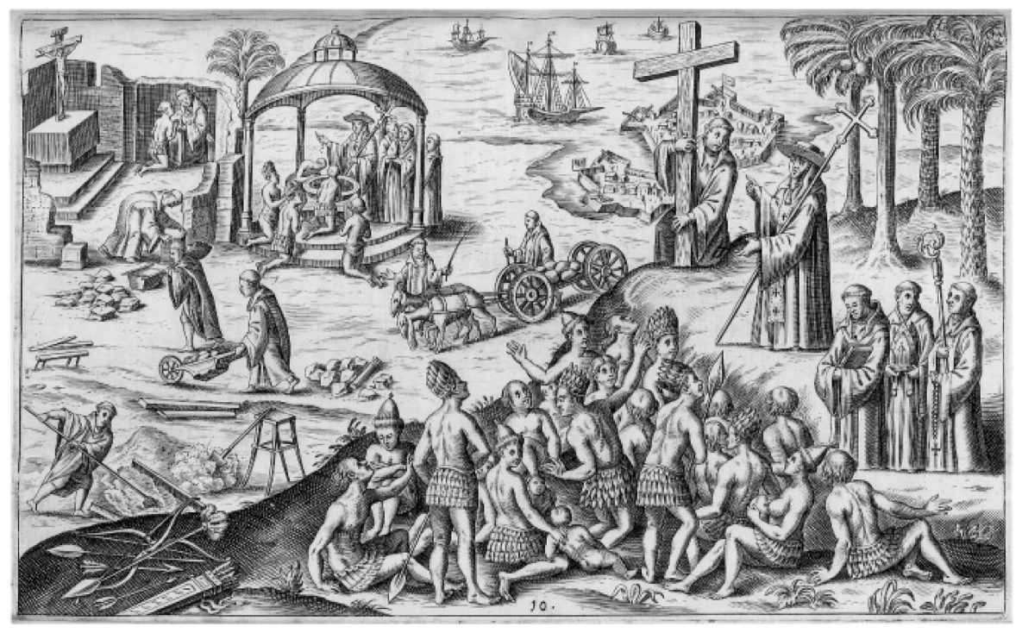

1. How does the image portray the Spanish? ______________________________________________________________________________________________ ___________________________________________________________________________________________________________________________________________________________________________________________________________________________________________________________________________________________________________________________________________________________________________________________________________________________________________________

2. Who is the Intended Audience of the image? (In other words, for whom is the artist creating the image?) Why is this important? ____________________________________________________________________________________________________________________________________ ___________________________________________________________________________________________________________________________________________________________________________________________________________________________________________________________________________________________________________________________________________________________________________________________________________________________________________________

3. What historical evidence could be used to challenge the Point of View of the image? _____________________________________________ ___________________________________________________________________________________________________________________________________________________________________________________________________________________________________________________________________________________________________________________________________________________________________________________________________________________________________________________
Directions: Below is a statement that is true. Provide THREE (3!) additional sentences that support the statement. (Historical Thinking Skill: Argumentation)
The Spanish developed a caste system in their colonies. _________________________________________________________________________________ ______________________________________________________________________________________________________________________________________________________________________________________________________________________________________________________________________________________________________________________________________________________________________________________________________________________________________________________________________________________________________________________________________________________________________________________________________________________________________________________________________________________________________________________________________________________________________________________________________________________________________________________________________________________________________

