Name: ____________________________________________________________________
APUSH Review: Video # : The Constitutional Convention, Compromises, and the Federalist Papers (Key Concept 3.2, II, C - E)

Background On The Constitutional Convention (Historical Context)

- Articles were designed to have a ___________ central government
- Annapolis Convention (1786)
  - Purpose was to improve the _______________________________
  - Only 5 states showed up
  - ________________________________________________ saved the day
  - Promise for another convention in 1787……

Constitutional Convention

- Delegates from _____ states went to Philly in 1787
  - Which state did NOT show up? ____________________________
- Structure of the government:
  - ___________________________ government - limits on what the federal government can do
  - Separation of powers and checks and balances
  - _____________________ - powers divided between states and federal government

Constitutional Compromises

- Congressional Representation:
  - ___________ Plan - proposed representation to be based on _____________________________
    - Would favor _________________ states
  - NJ Plan - proposed representation to be _____________ per state (similar to Articles)
  - Great Compromise
    - Combined elements of VA and NJ Plans
    - 1 part of legislature would be based on population (_________________________________________)
    - 1 part of legislature would be equal representation (__________________________ per state)
- 3/5 Compromise:
  - 3/5 (60%) of ____________ would count towards ________________________________________________ in the House
    - Favored _________________________ states
- Slave Trade Compromise:
  - Congress could not allow the international slave trade until 1808 (which they did)

Ratification Debates

- Federalists - those that supported the ____________________________ of the Constitution
- Anti-Federalists - those that _________________________ ratifying the Constitution
- ___________________________________________________:
  - ________ essays to defend the Constitution and encourage ratification
  - Federalist #10 - factions and controlling factions
  - Federalist #51 - Separation of Powers and Checks and Balances
- So… why did Anti-Federalists ultimately ratify the Constitution?
  - The Federalists promised to add a __________________________ ___________________________________________________________________!
    - 1st Ten amendments
    - Restrict powers of the federal government and preserve _____________________ and freedoms

The Bill Of Rights

- 1: Five Freedoms
  - Religion, Assembly, Press, ____________________, and Speech
- 2:
  - Right to bear ___________
- 3:
  - No quartering of __________________________
- 4:
  - No unreasonable search and _____________________
- 5:
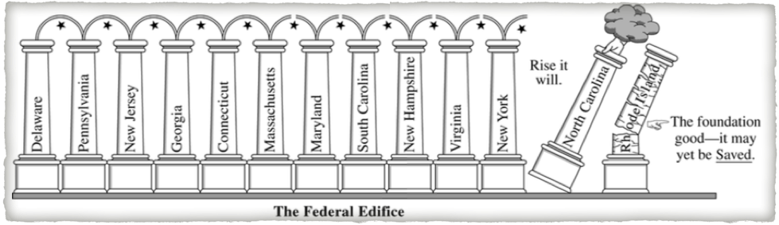
  - Grand jury; no ________________________________; can’t testify against yourself; can’t lost property, life, or liberty without a trial
- 6:
  - Speedy trial; right to an _____________________________; cross examination; witnesses that are favorable
- 7:
  - Jury trial in a civil suit
- 8:
  - No cruel and unusual __________________________________
- 9:
  - Rights not listed are not necessarily _______________________
- 10:
  - Powers not delegated (given) to the federal government are reserved for the ________________________ or people

Quick Recap

- Annapolis Convention
- __________________ Compromise
- __________________ Compromise
- __________________ Trade Compromise
- Federalist Papers
- Bill of Rights

Part II

(Historical Thinking Skill: Analyzing Evidence)
1. What is the Point of View of the political cartoon? Why is this important? _______________________________________________________________ ____________________________________________________________________________________________________________________________________________________________________________________________________________________________________________________________________________________________________________________________________________________________________________________________________________________________________________________________________________________________________________________________________________________________________________________________________________________________________________________________________________________________________________

2. Why, ultimately, did the Anti-Federalists agree to ratify the Constitution? ____________________________________________________________ ____________________________________________________________________________________________________________________________________________________________________________________________________________________________________

Compare and Contrast the structure and powers of the federal government under the Articles of Confederation and the Constitution. (8-10 sentences). (Historical Thinking Skill: Comparison). __________________________________________________________________________________________ _________________________________________________________________________________________________________________________________________________________________ ______________________________________________________________________________________________________________________________________________________________________________________________________________________________________________________________________________________________________________________________________________________________________________________________________________________________________________________________________________________________________________________________________________________________________________________________________________________________________________________________________________________________________________________________________________________________________________________________________________________________________________________________________________________________________________________________________________________________________________________________________________________________________________________________________________________________________________________________________________________________________________________________________________________________________________________________________________________________________________________________________________________________________________________________________________________________________________________________________________________________________________________________________________________________________________________________________________________________________________________________________________________________________________________________________________________________________________________________________________________________________________________________________________________________________________________________________________________________________________________________________________________________________________________________________________________________________________________________________________________________________________________________________________________________________________________________________________________________________________________________________________________________________________________________________________________________________________________________________________________________________________________________________________________________________________________________________________________________________________________________________________________________________________________________________________________________________________________________________________________________________________________________________________________________________________________________________________________________________________________________________________________________________________________________________________________________________________________________________________________________________________________________________________________________________________________________________________________________________________________________________________________________________________________________________________________________________________________________________________________________________________________________________________________________________________________________________________________________________________________________________________________

