Name: ________________________________________________
APUSH Review: Video #19: Early 1800s Political Parties, Louisiana Purchase, War of 1812, And The Monroe Doctrine

Early 1800s Political Parties

- Parties debated the following issues:
  - ______________________________
    - Federalists favored tariffs, Democratic-Republicans opposed
  - Powers of the federal government
    - Ironically, Federalists opposed a __________________ interpretation of the Constitution -> ______________ __________________________
    - Democratic-Republicans tended to favor states’ rights

The Louisiana Purchase

- Thomas Jefferson sought to purchase _____________________________ from the French
- Napoleon offered all of Louisiana for $_________ million!
- ______________________________ the size of the US
- Jefferson switched from ____________________________________________

War Of 1812

- War with Great Britain
  - ________________________________________________________________________________________________________________________________
- “___________________________” from the South and West favored war
  - Federalists were _____________________ war with England
    - Merchants were hurt by the ________________________ ________________________________________________________
- ____________________________ was gained or lost by either side

Impacts Of The War Of 1812

- The war made two generals popular and future presidents
  - ____________________________________________________ - Battle of Tippecanoe
  - Andrew Jackson - Battle of _________________________________
- Hartford Convention (end of war)
  - New England federalists gathered at Hartford
  - Proposed _________________________________ the Constitution
    - 1 term for president, 2/3 Congress to approve embargoes and declare war
  - Some delegates urged ______________________________________

Monroe Doctrine

- US sought to keep Europe from ____________________________________ Latin America
- The US warned Europe to stay out of ______________________________ Hemisphere
- In return, the US would ______________________ of European affairs
  - Continuation of Washington’s Farewell Address
- More ______________________ in the short term, used later under TR

Quick Recap

- Differences between early 1800s political parties
- Impacts of the LA Purchase
- Causes and impacts of War of 1812
- Monroe Doctrine

Part II

The following questions are based on the following document. (Historical Thinking Skill: Analyzing Evidence)
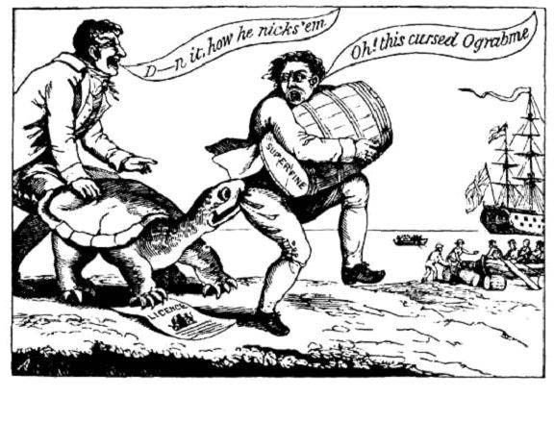
Smuggler
Read “Ograbme” backwards. What does it say?
British Ship
1. What is the author’s Point of View towards the Embargo Act? Why is this significant? ____________________________________________________________ _________________________________________________________________________________________________________________________________________________________________

2. What region(s) of the country would support the author’s Point of View? Who would oppose it?
- Region(s) that would support: ______________________________________________________________________________________________________________________ _________________________________________________________________________________________________________________________________________________________
- Region(s) that would oppose: _______________________________________________________________________________________________________________________ _________________________________________________________________________________________________________________________________________________________

Sentence Prompts (Historical Thinking Skill: Argumentation)
Directions: Below are statements that is true. Provide THREE (3!) additional sentences that support the statement.

There was much debate over the Louisiana Purchase. ____________________________________________________________________________________________________ ______________________________________________________________________________________________________________________________________________________________________________________________________________________________________________________________________________________________________________________________________________________________________________________________________________________________________________________________________________________________________________________________________________________________________________________________________________________________________________________________________________________________________________________________________________________________________________________________________________________________________________________________________________________________________________________________________________________________________________________________________

Even though no land was gained or lost, the War of 1812 had significant impacts. ____________________________________________________________________ ______________________________________________________________________________________________________________________________________________________________________________________________________________________________________________________________________________________________________________________________________________________________________________________________________________________________________________________________________________________________________________________________________________________________________________________________________________________________________________________________________________________________________________________________________________________________________________________________________________________________________________________________________________________________________________________________________________________________________________________________________

