Name: ____________________________________________________________________
APUSH Review: Video #23: Sectionalism & The American System (Key Concepts 4.2, III, B - D)

Sectionalism

- As the 19th century progressed, the North and South became more ____________________________________________ in their economies
  - South:
    - Cotton production and agricultural staples
  - North:
    - Focused on __________________________________________, banking, and shipping industries
- Both regions traded goods to ______________________________________ __________________________________ in Europe

Impacts Of Cotton On The Economy

- US economy increased during this time due to:
  - Southern cotton production
    - Sold to the North and Europe
  - Northern manufacturing
    - Cotton used in textile factories
  - ________________________
    - Loans to foster the growth of industry
  - Shipping industries
    - Northern merchants made $ from sale of cotton and international trade
- As the North industrialized, the South continued to produce staple crops and cash crops
- _____________________________________________________________ exercised tremendous power
- Many elites defended slavery and the Southern Way of life
  - ____________________________________________________

Henry Clay’s American System

- Background Info (Historical Context)
  - During the early 19th century, the country faced many challenges:
    - Infant US industries had a hard time competing with British goods (____________ War of 1812)
    - ____________________________________________ was weak (especially in the West - KY, OH, TN, etc.)
    - 1st BUS expired and 2nd BUS was ________________________________ in 1816 for 20 years
- The goal of the American System was to address these areas

Henry Clay’s American System – The BUS

- 1st BUS created divisions between Jefferson and Hamilton
  - Debate over __________________________________________________ interpretation of the Constitution
- The Supreme Court upheld the Constitutionality of the BUS in McCulloch v. Maryland in 1819
  - However opposition still persisted
    - Andrew Jackson’s ________________ of the 3rd BUS
- Henry Clay advocated the 3rd BUS - help stimulate the economy

Henry Clay’s American System – Internal Improvements

- Inter v. Intra state trade:
  - Interstate involves trade between ________ or more states
  - Intrastate trade involves trade ____________________ a state
  - For much of early American History, Congress only provided funding for _______________________________________ developments
- The American System advocated federal funds to improve infrastructure - increase trade and connectivity of the country
  - Many politicians, such as Andrew Jackson opposed this
    - _________________________________ Rd. veto in KY
    - James Monroe’s veto of the _________________ Canal
- How would the American System pay for these internal improvements?
  - ____________________________!

Henry Clay’s American System - Tariffs

- Tariff:
  - Tax on ________________________________ goods
  - Price of foreign goods increases, provides revenue for government, and makes ____________________________________ products more appealing
- Tariff of 1816, 1828, and 1832:
  - Raised the price of foreign goods
    - Idea was to _______________ American industries
    - Much ____________________________ to 1828 and 1832
    - Nullification Crisis in SC

Analyzing The American System

- Successes:
  - North and _______________________ were more closely linked
  - Many states built up their __________________________________
  - 1st of many government sponsored programs in the economy
  - American industries were able to prosper
- Failures:
  - Did not _____________________ all areas of the US
  - Sectionalism increased (Nullification Crisis)
  - Continued debates about role of ___________________________ government in intrastate business

Quick Recap

- Impacts of cotton on the economy
- 3 parts of the American System
  - BUS
  - Internal Improvements
  - Tariffs
- Successes and failures of the American System

Part II

Identify and Describe the Three Parts of Henry Clay’s American System

Part II: ______________________________ __________________________________________________________________________________________________________________________________________________________________________________________________________________________________________
Part III: _____________________________ __________________________________________________________________________________________________________________________________________________________________________________________________________________________________________
Part I: _______________________________ __________________________________________________________________________________________________________________________________________________________________________________________________________________________________________

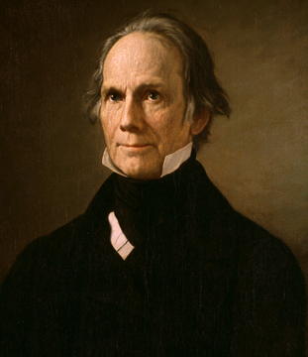
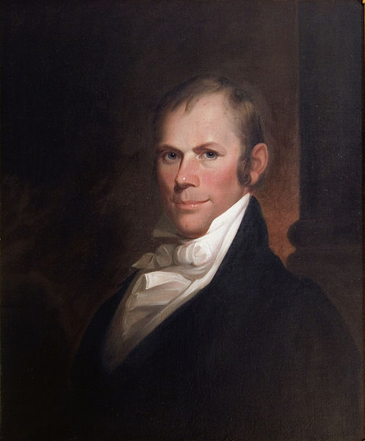

Henry Clay’s American System!

1. How would the following people most likely view the American System? Why?
- Alexander Hamilton: _________________________________________________________________________________________________________________________________ __________________________________________________________________________________________________________________________________________________________________________________________________________________________________________________________________________________________________________________
- Thomas Jefferson from the 1790s: __________________________________________________________________________________________________________________ __________________________________________________________________________________________________________________________________________________________________________________________________________________________________________________________________________________________________________________
2. What did the Supreme Court state about the Bank of the US in its 1819 decision, McCulloch v. Maryland? _______________________________________ _________________________________________________________________________________________________________________________________________________________________
Part II Document Analysis

“Sir, I am convinced that it would be… unjust, to aggravate the burdens of the people for the purpose of favoring the manufacturers; for this government created and gave power to Congress to regulate commerce and equalize duties on the whole of the United States, and not to lay a duty but with a steady eye to revenue. With my goodwill, sir, (no) one interest in the country (should be) sacrificed by the management of taxation to another… The agriculturalists bear the whole brunt of the war and taxation, and remain poor, while the others run in the ring of pleasure, and fatten upon them.” – John Randolph, 1816 (Historical Thinking Skill: Analyzing Evidence)

1. What is the message of the document? __________________________________________________________________________________________________________________ __________________________________________________________________________________________________________________________________________________________________________________________________________________________________________________________________________________________________________________________________

2. What is the Point of View of the document? _____________________________________________________________________________________________________________
__________________________________________________________________________________________________________________________________________________________________________________________________________________________________________________________________________________________________________________________________

3. The excerpt was likely to have found the most support among which of the following groups?
- New England merchants
- Factory workers in the North
- Plantation owners in South Carolina
- Irish immigrants that helped build the Erie Canal

Complete the following prompt with at least three additional sentences that supports the prompt. (Historical Thinking Skill: Argumentation)

1. The American System was somewhat successful. ______________________________________________________________________________________________________ __________________________________________________________________________________________________________________________________________________________________________________________________________________________________________________________________________________________________________________________________
______________________________________________________________________________________________________________________________________________________________________________________________________________________________________________________________________________________________________________________________________________________________________________________________________________________________________________________________________________________________________________________________________________________________________________________________________________________________________________________________________________________________________________________________________________________________________________________________________________________________________________________________________________________________________________________________________________________________________________________________________
__________________________________________________________________________________________________________________________________________________________________________________________________________________________________________________________________________________________________________________________________

