Name: ____________________________________________________________________
APUSH Review: Video #31: Nativism (Key Concepts 5.1, II, A - B)

Immigration

- Immigrants from Asia settled on the West Coast
  - ______________________ in the 1850s
    - Worked in gold mines, factories, __________________, and farming
    - Later, the _____________________________________________ ________________ (1882) forbid Chinese immigrants
- European Immigrants:
  - Irish - settled in the ________________________________________ - mostly Catholic
  - Germans - settled on the “frontier” - _______________________ - as _________________________________
  - Many immigrant children attended parochial schools

Nativism

- What is it?
  - Fear, distrust, dislike of _____________________________________
  - Often anti-______________________________
- Nativist groups sought to ____________________________ immigrants’ ________________________________________________________________________

Know-Nothing Party

- What is it?
  - Political Party that formed due to _________________________
- Originated as the Supreme Order of the Star Spangled Banner
  - Wanted to ban Catholics from holding ____________________
  - Called for ________________ immigration and naturalization laws
- In 1856, Ex-President Millard Fillmore ran for president for the Know-Nothing Party
  - Won _________% of the popular vote

Quick Recap

- Immigrant groups
- Where did they settle
- Nativism
- Know-Nothing Party

Part II

(Historical Thinking Skill: Analyzing Evidence)
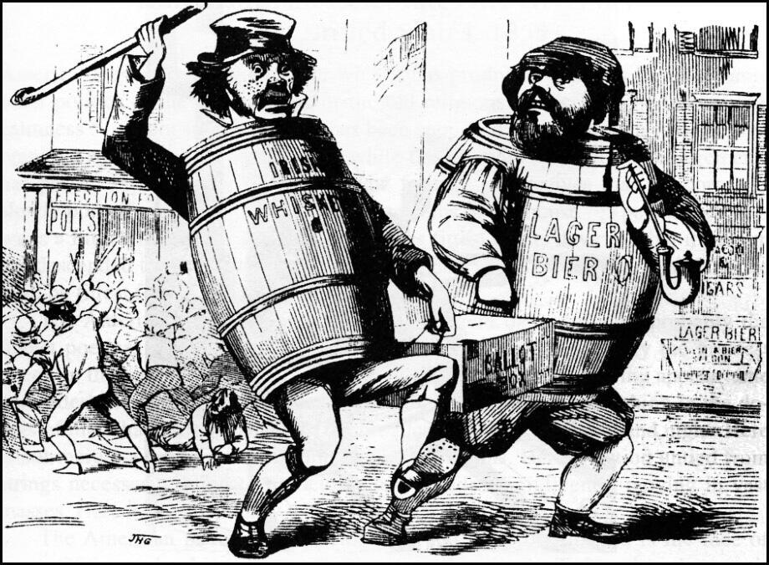

1. The creator of the image would most likely agree with which of the following statements?
- Irish and German Immigrants made positive contributions to American society
- Rising xenophobia should not be a concern of Americans
- Immigrants’ political power should be limited
- Immigrants should retain their religious and cultural practices in the United States

2. The immigrants represented in the cartoon most likely settled in which two regions of the United States?
- The Northeast and Midwest
- The South and Southwest
- The West Coast and Great Plains
- The Pacific Northwest and Southwest

Sentence Prompts (Historical Thinking Skill: Argumentation)

1. Nativism increased in American in the 1840s and 1850s. _____________________________________________________________________________________________ ____________________________________________________________________________________________________________________________________________________________________________________________________________________________________________________________________________________________________________________________________________________________________________________________________________________________________________________________________________________________________________________________________________________________________________________________________________________________________________________________________
__________________________________________________________________________________________________________________________________________________________________________________________________________________________________________________________________________________________________________________________________

2.

