Name: ___________________________________________________
APUSH Review: Unit 1, Learning Objective A (Topic 1.1)

Objective: Explain the context for European encounters in the Americas from 1491 - 1607.

APUSH Test Tip
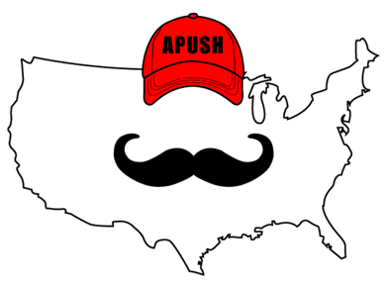
- Contextualization is a significant skill you must understand to succeed in APUSH. Understanding the ______________________ of this time period is important for contextualization.

What Is Contextualization?

- Big idea of what is going on ________________ a time period
- Think the Star Wars ___________ in the movies
  - Gives ____________________________ for what you’re about to watch
- When writing essays, contextualization can go in the _______________ paragraph
  - __________ sentences

Why Were These Dates (1607 – 1754) Chosen?

- 1491 is one year _________________ to Columbus’ voyage
  - Native Americans were _______________________ from Europe PRIOR to Columbus
- In 1607, England founded ___________________________
- Most of this unit will focus on:
  - Native American life prior to Columbus
  - _______________________ colonization of the Americas

Native Americans Before 1492

- Diverse societies that adapted to their environments
  - ____________ (Great Plains)
  - Farming (________________)
  - Irrigation systems

Columbian Exchange

- ____________________________________________________________________________________________________________ between the Americas, Europe, and Africa
- Forever changed the life/society in the three continents

Impacts Of Contact On Europe

- Population ___________________ (potatoes, maize)
- Development of _____________________
  - __________________________________________________________________________________________

Impacts Of Contact On Native Americans

- Population decreased drastically
  - ____________________
- Enslavement of Natives
  - ________________________ System

Impacts Of Contact On Africans

- Atlantic Slave trade
  - Started by ___________ and _____________________
- ________________________________:
  - Forced migration of Africans to the Americas
- _______________________ Slavery:
  - System in which enslaved individuals could be bought and sold at will; ___________ would be enslaved as well

Differing Worldviews Between Natives And Europeans

- Each group had different worldviews in regards to
  - ______________________
  - ______________________ Roles
  - ______________________ Use
- Will be discussed in more detail in topic 1.6

Part II Document Questions

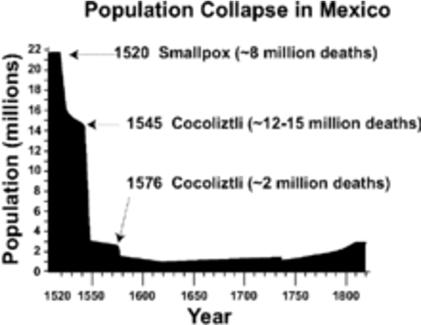
What were reasons for the drastic decline of Native American populations in Mexico, as shown in the image? __________________ ____________________________________________________________________________________________________________________________________________________________________________________________________________________________________

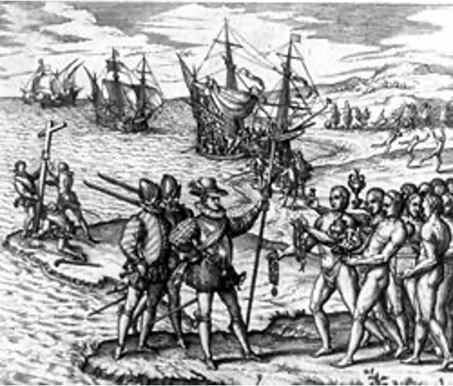
What does the cross in the left side of the painting suggest about motives for exploration? ____________________________________ ____________________________________________________________________________________________________________________________________________________________________________________________________________________________________

