Name: ___________________________________________________
APUSH Review: Unit 1, Learning Objective B (Topic 1.2)

Objective: Explain how and why various native populations in the period before European contact interacted with the natural environment in North America.

APUSH Test Tip
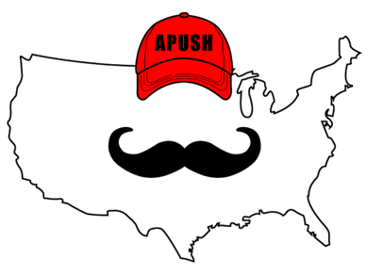
- If you encounter an essay topic on the Columbian Exchange or the impacts of European exploration on the Western Hemisphere, a brief description of this topic could count as your contextualization point in the essay.

Must Know Regions Where Natives Lived

- Mexico and the American Southwest
- Great Plains and the Great Basin
- Northeast, Mississippi River Valley, and Atlantic seaboard
- Northwest and California

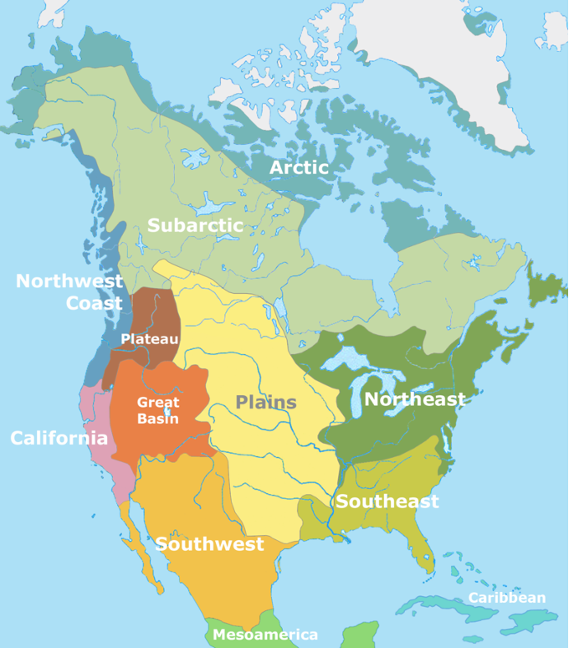
Mexico And The American Southwest

- Focused heavily on _________________ (corn) cultivation
  - Led to ________________________________ villages and settlements
    - Emergence of ___________ classes
- Pueblos developed _______________________ systems

Great Plains And The Great Basin

- Central part of US
- Natives adapted to the environment by:
  - Being ___________________ and hunting bison and sheep
  - _________________________, no permanent settlements
- Post European contact:
  - ________________________________________________ made hunting more efficient

Northeast, Mississippi River Valley, and Atlantic Seaboard

- Focused on hunting and gathering and agriculture
  - _______________________ villages developed
- __________________ (Near present-day St. Louis)
  - 10,000 people in 1200 C.E.
- __________________ (present day New York)
  - Burned forests to hunt animals and grow crops
  - Villages built around ______________________

Northwest And California

- Focused on hunting, gathering, and _________________________
  - Nuts, fish, and hunt animals
- ______________ resources helped support Native American populations

Part II

- Complete Venn Diagram based on the following prompt:
  - “Compare and contrast the similarities and differences between Native Americans in the Great Plains and Great Basin with Native Americans in the Northeast.”

