Name: ___________________________________________________
APUSH Review: Unit 1, Learning Objective C (Topic 1.3)

Objective: Explain the causes of exploration and conquest of the New World by various European nations.

APUSH Test Tip

- Like the previous topic, information from this topic could count towards __________________________________ on an essay about impacts of European contact on the Americas. Discussing why Europeans were able to travel to the Americas would serve as a great example of contextualization.

Reasons For European Exploration And Conquest
Think # Gs – Gold, Glory, and God
- Search for new sources of _______________
- Economic and military competition
- Desire to spread ________________________

Search For New Sources Of Wealth

- Europeans sought an overseas route to __________
  - _____________________ to sell goods
  - Acquire _________________________________________
- ___________________ acquired gold and silver in the Americas
  - Other European nations searched for precious metals as well

Economic And Military Competition

- Spain and Portugal dominated early exploration
- English defeat of the _____________________________________ ___________________________________ (1588)
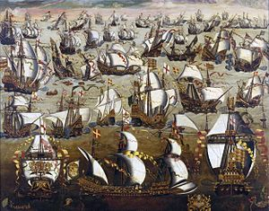
  - England emerged as a ______________ power
  - Spurred English _______________________ of the Americas

Desire To Spread Christianity

- Spain sought to spread _______________________ to other parts of the world
- Spain established ____________________________
  - Buildings throughout North and South America that converted _______________________________________ to Catholicism
  - Example of a Mission?
    - The ______________!

Part II

Rank the reasons for exploration from most significant (1) to least significant (3). Explain why you chose (1) to be the most significant.

1. _______________________________________________________
2. _______________________________________________________
3. _______________________________________________________

The reason I chose ______________________________________________________ for number 1 is because _______________________________________
__________________________________________________________________________________________________________________
______________________________________________________________________________________________________________________________________________________________________________________________________________________________________________________________________________________________________________________________________________________

