Name: ___________________________________________________
APUSH Review: Unit 1, Learning Objective D (Topic 1.4)

Objective: Explain causes of the Columbian Exchange and its effect on Europe and the Americas during the period after 1492

APUSH Test Tip

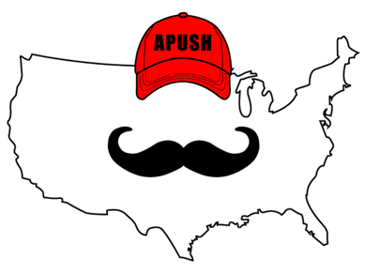
- The Columbian Exchange might be the most important topic so far in the curriculum. This refers to the _________ _________________________________ _________________________________ _________________________________ _________________________________. None of these regions were the same after this event. This is a great topic to appear on multiple-choice and short answer questions. Make sure you know the impact on each region

Causes Of The Columbian Exchange

- New maritime technology:
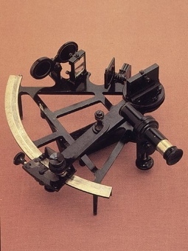
  - When the ___________________ (determines latitude) and caravel (faster ship) were invented, this led to further exploration
- Formation of ______________________ companies:
    - People would pool their money together (invest) and share in profits and losses of explorations
    - Precursor to ______________________ later

Effects Of Columbian Exchange On The Americas

- Diseases (______________________________) devastated Native American populations
  - Some areas saw population decline by ______%
- Introduction of new animals
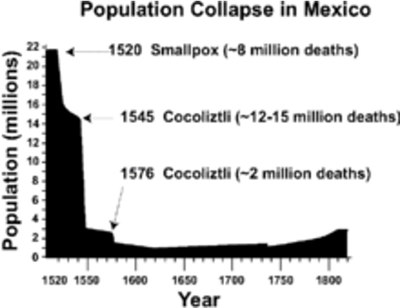
  - ____________________ - transformed life for Natives living on Great Plains and Great Basin
- Introduction of new crops:
  - _____________________ __________________________ - grown in the South and Caribbean -> arduous labor

Effects Of Columbian Exchange On Europe

- Introduction of new crops:
  - ________________________________________________ (corn) led to a population growth in Europe
- Influx of _______________________________________________ (gold and silver)
  - Europe shifted from feudalism to ____________________

Part II - Short Answer Question

- Briefly explain one impact of the Columbian Exchange on the Americas
- Briefly explain one additional impact of the Columbian Exchange on the Americas
- Briefly explain one impact of the Columbian Exchange on Europe

______________________________________________________________________________________________________________________________________________________________________________________________________________________________________________________________________________________________________________________________________________________
___________________________________________________________________________________________________________________________________________________________________________
___________________________________________________________________________________________________________________________________________________________________________
___________________________________________________________________________________________________________________________________________________________________________
___________________________________________________________________________________________________________________________________________________________________________
___________________________________________________________________________________________________________________________________________________________________________
___________________________________________________________________________________________________________________________________________________________________________
___________________________________________________________________________________________________________________________________________________________________________
___________________________________________________________________________________________________________________________________________________________________________
___________________________________________________________________________________________________________________________________________________________________________
___________________________________________________________________________________________________________________________________________________________________________
___________________________________________________________________________________________________________________________________________________________________________
___________________________________________________________________________________________________________________________________________________________________________
___________________________________________________________________________________________________________________________________________________________________________
___________________________________________________________________________________________________________________________________________________________________________
___________________________________________________________________________________________________________________________________________________________________________

