Name: ___________________________________________________
APUSH Review: Unit 1, Learning Objective E (Topic 1.5)

Objective: Explain how the growth of the Spanish Empire in North America shaped the development of social and economic structures over time.

APUSH Test Tip

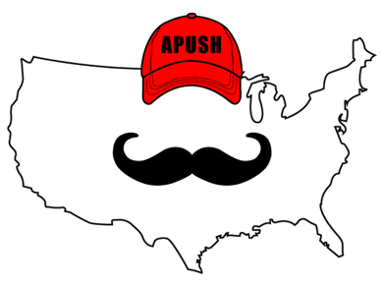
- This topic covers the structure of the Spanish Empire in the Americas. This will be important to know for the next unit (#2) when you will be expected to __________________________________ __________________________________ the Spanish Empire with other European Empires. Make sure you can explain the major characteristics of the Spanish Empire.

The Growth Of The Spanish Empire
- Spanish Conquistadores:
  - Hernan Cortes - conquered _______________ in 1519
  - Francisco Pizzaro - conquered ___________ in 1521
- Spain quickly conquered much of present-day Latin America during this time period
  - _____________________________________ (1494)
    - Treaty between Spain and _________________ that gave much of Latin America to Spain

***Encomienda System***

- Native American labor was ____________________ (arranged, assembled) on plantations
- The goal was to use labor for agriculture and _____________________________________ in mines
- Eventually, the system was replaced by ___________________ enslaved labor

Growth Of Slavery

- Europeans partnered with some ________________________ groups that practiced slavery:
  - Forcibly extracted slave labor for the Americans
- Spanish imported enslaved Africans to labor on ____________________ and mines
  - Sugar plantations in the _________________________

Social Structure Of New Spain

- ____________ group of individuals (Europeans, African, and Native Americans)
- Spanish Caste System:
  - Incorporated diverse group and defined their position in society
  - The farther down the caste system, the less ___________________ and political power one had
  - The more _____________________ an individual was, the higher up the caste system they were

Part II - Document Analysis

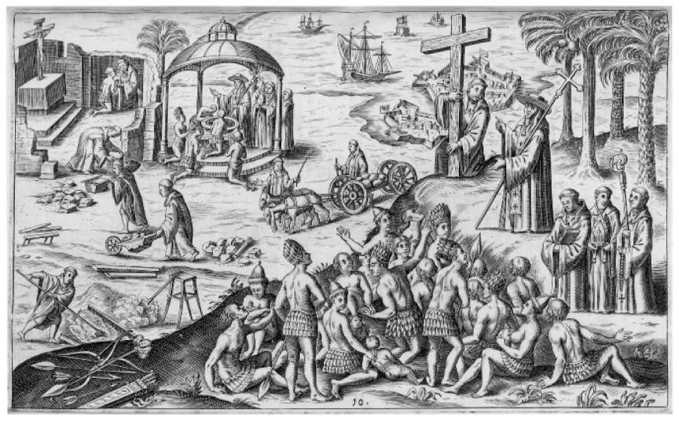
Spanish Colonization Illustration from 1621
- What is the Point of View of the above image?
  - Positive towards Spanish colonization
  - Spain is Christianizing Natives
- What is specific historical evidence that could be used to challenge the above illustration?
  - Encomienda System, Spanish Caste System

- What is the Point of View of the above image?
  - _____________________________________________
  - _____________________________________________
- What is specific historical evidence that could be used to challenge the above illustration?
  - __________________________________________________________________________________________

