Name: ___________________________________________________
APUSH Review: Unit 2, Learning Objective A (Topic 2.1)

Objective: Explain the context for the colonization of North America from 1607 to 1754.

APUSH Test Tip
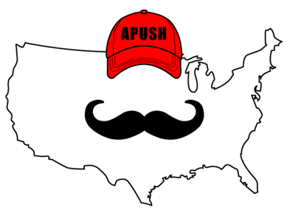
- This unit is a heavily tested segment of the APUSH curriculum. You will need to know the __________________________ of European colonization as well as characteristics of English colonies. Being able to compare and contrast these characteristics will help you be successful in the course.

Why Were These Dates (1607 - 1754) Chosen?

- In 1607, England founded _____________________, VA
  - First _______________________ English settlement
- France founded _____________ in 1608
- 1754 marked the start of the 7 Years’ (French and Indian) War
- The years in between 1607 and 1754 focus on European countries inhabiting these new colonies

Big Ideas For This Unit - European Colonizers

- 4 major European countries colonized North and South America:
  - England
  - ____________________
  - Spain
  - _________________
- Be able to explain characteristics of each country (next PowerPoint - topic 2.2)
  - Great Short Answer Question/LEQ

Big Ideas For This Unit - British 13 Colonies

- Britain established the ____ colonies, as well as colonies in the ___________________
  - Be able to compare/contrast New England colonies with Middle and Southern colonies (2 PowerPoints from now - topic 2.3)
  - Great Short Answer Question/LEQ

Big Ideas For This Unit - Slavery

- Slavery existed in _______ 13 colonies
- Causes for the growth of slavery include:
  - Abundance of ___________
  - European __________________ for colonial goods
  - ____________________________ of indentured servants
- Responses to slavery by enslaved individuals:
  - ______ and __________ methods of resisting enslavement

Big Ideas For This Unit - Native American Conflicts

- Native American responses to interactions with Europeans
  - ___________________ Revolt (Spain)
  - ___________________ (King Philip’s) War (England)
  - Be able to compare/contrast these conflicts

Big Ideas For This Unit - Mass Social Movements

- The 1st Great Awakening
  - Mass __________________________________ movement in the colonies
  - An example of resistance to established _______________
  - Be able to compare/contrast with the _________________

Part II: John Winthrop - Massachusetts Bay Colony
“For we must consider that we shall be as a city upon a hill. The eyes of all people are upon us. So that if we shall deal falsely with our God in this work we have undertaken, and so cause Him to withdraw His present help from us, we shall be made a story and a by-word through the world.”

- What is the message of the excerpt? ________________________ ______________________________________________________________________________________________________________________________________________________________________________________________________________________________________________________________________________
- How does Winthrop view his people? _______________________ ______________________________________________________________________________________________________________________________________________________________________________________________________________________________________________________________________________
- What is the Point of View of the excerpt? ____________________ ______________________________________________________________________________________________________________________________________________________________________________________________________________________________________________________________________________

